Tokenize function

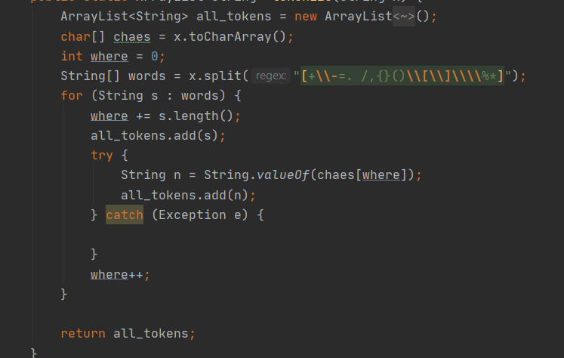

You can find in p1.txt,p2.txt,p3.txt,p1err.txt the programs from the first lab and in st1.out,st2.out,st3.out,sterr.out you can find the symbol table according to each problem and in the pif1.out,pif2.out,pif3.out,piferr.out you can find the pif table according to each problem and in the message1.out….. you can find the message for each program if it’s lexically correct or not.